CIRCUIT 3 REPORT

- Description Of Modules
*** pH Sensor ***
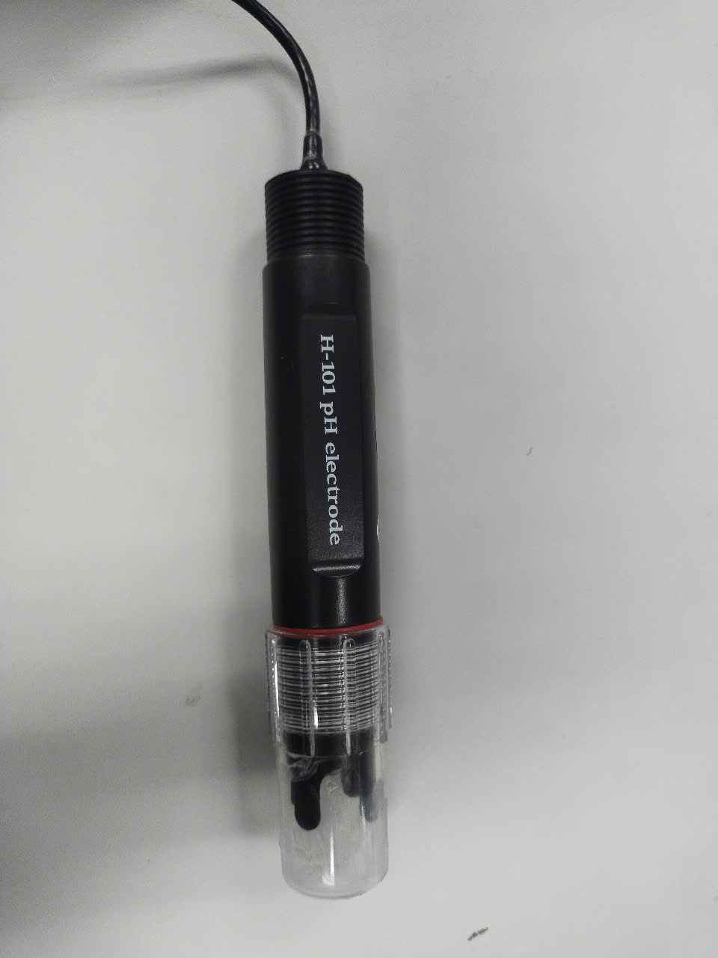
pH Sensor
Measuring pH of water.

*** Temperature Sensor ***
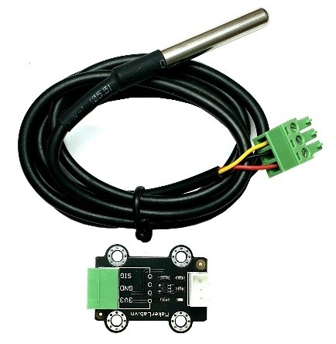
Temperature Sensor
Measuring temperature in a water environment helps reduce the error of the pH sensor

*** SD Card ***
Write all collected data from above modules into micro card as file .csv.

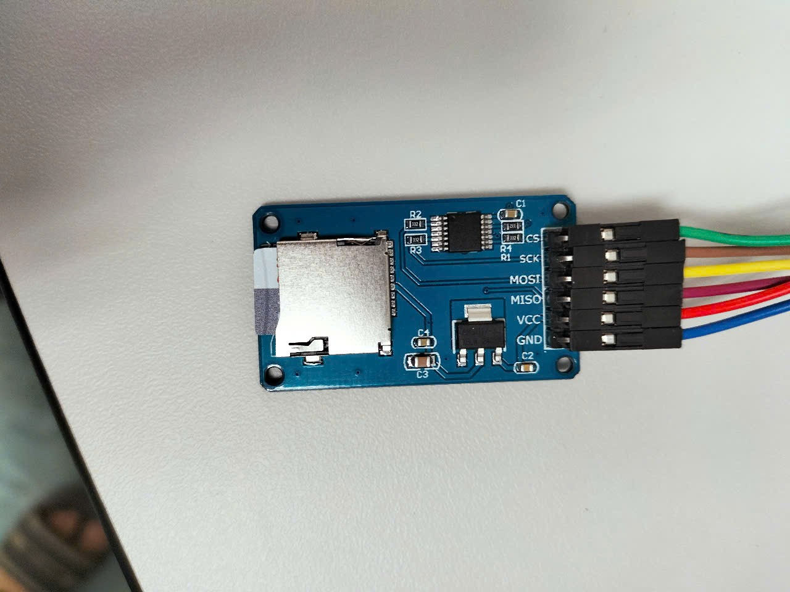
SD Card

- Pinout Diagram
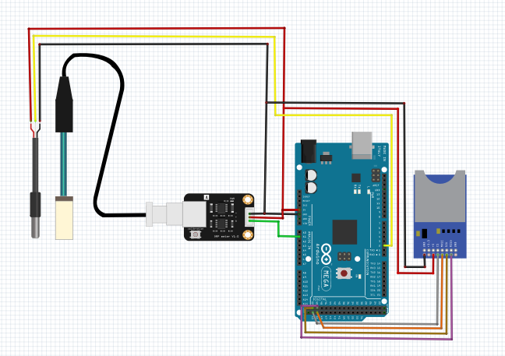

Mega | Temperature Sensor | pH Sensor | SD
5V | + | + | 3.3v
GND | - | - | GND
51 |  |  | Mosi
50 |  |  | Miso
52 |  |  | SCK
53 |  |  | CS
A1 |  | analog
2 | digital

- Code

- #include <Wire.h>
- #include <Adafruit_Sensor.h>
- #include <Adafruit_BNO055.h>
- #include <SD.h>
- #include <SPI.h>

- #define CHIP_SELECT 10 // Chân CS cho SD Card
- Adafruit_BNO055 bno = Adafruit_BNO055(55);

- File myFile;

- void setup() {
- Serial.begin(115200);

- // Khởi động BNO055
- if (!bno.begin()) {
- Serial.println("Không tìm thấy BNO055!");
- while (1);
- }
- delay(1000);
- bno.setExtCrystalUse(true);

- // Khởi động SD Card
- Serial.print("Đang khởi tạo SD card...");
- if (!SD.begin(CHIP_SELECT)) {
- Serial.println("Lỗi! Không thể khởi tạo thẻ SD.");
- while (true);
- }
- Serial.println("Thành công!");

- // Kiểm tra file CSV, nếu chưa có thì ghi tiêu đề
- myFile = SD.open("M4.csv", FILE_READ);
- if (!myFile) {
- writeHeader();
- }
- myFile.close();
- }

- // Ghi tiêu đề vào file CSV
- void writeHeader() {
- myFile = SD.open("M4.csv", FILE_WRITE);
- if (myFile) {
- myFile.println("AccelX,AccelY,AccelZ,GyroX,GyroY,GyroZ,MagX,MagY,MagZ");
- myFile.close();
- Serial.println("Ghi tiêu đề vào M4.csv.");
- } else {
- Serial.println("Lỗi mở file M4.csv.");
- }
- }

- void loop() {
- sensors_event_t accel, gyro, mag, temp;
- bno.getEvent(&accel, Adafruit_BNO055::VECTOR_ACCELEROMETER);
- bno.getEvent(&gyro, Adafruit_BNO055::VECTOR_GYROSCOPE);
- bno.getEvent(&mag, Adafruit_BNO055::VECTOR_MAGNETOMETER);

- unsigned long timeStamp = millis();

- Serial.print("Time: "); Serial.print(timeStamp);
- Serial.print(" | Accel: "); Serial.print(accel.acceleration.x); Serial.print(", ");
- Serial.print(accel.acceleration.y); Serial.print(", ");
- Serial.print(accel.acceleration.z);
- Serial.print(" | Gyro: "); Serial.print(gyro.gyro.x); Serial.print(", ");
- Serial.print(gyro.gyro.y); Serial.print(", ");
- Serial.print(gyro.gyro.z);
- Serial.print(" | Mag: "); Serial.print(mag.magnetic.x); Serial.print(", ");
- Serial.print(mag.magnetic.y); Serial.print(", ");
- Serial.println(mag.magnetic.z);

- // Ghi dữ liệu vào file CSV
- myFile = SD.open("M4.csv", FILE_WRITE);
- if (myFile) {
- myFile.print(accel.acceleration.x); myFile.print(",");
- myFile.print(accel.acceleration.y); myFile.print(",");
- myFile.print(accel.acceleration.z); myFile.print(",");
- myFile.print(gyro.gyro.x); myFile.print(",");
- myFile.print(gyro.gyro.y); myFile.print(",");
- myFile.print(gyro.gyro.z); myFile.print(",");
- myFile.print(mag.magnetic.x); myFile.print(",");
- myFile.print(mag.magnetic.y); myFile.print(",");
- myFile.println(mag.magnetic.z);
- myFile.close();
- } else {
- Serial.println("Lỗi khi ghi vào file BNO055.csv.");
- }

- delay(100); // Cập nhật mỗi 100ms
- }

